LAB 4_ LED matrix interfacing with PIC controller

1. Objective:
- To be familiar with PIC Microcontroller
- To be familiar with PIC16F877A Microcontroller internal and external structure and its configuration.
- To know how a the led matrix interfacing with pic microcontroller .
2. Required Components
Table 1. Components
Qty. | Component Name
1 | PIC18F4550
1 | BreadBoard
1 | Led matrix
5 | Push Buttons
1 | Resistors Kit
1 | Capacitors Kit
1 | Jumper Wires Pack
1 | LM7805 Voltage Regulator (5v)
1 | Crystal Oscillator
1 | PICkit2 or 3 Programmer
1 | 9v Battery or DC Power Supply

3. Introduction
3.1 How does a 7 segment display work?
LED dot matrices are available in various dimensions (7×5,8×8, 7x15etc). 8×8 is shown below which contains 8 rows and 8 columns. An LED is connected between row and column. Each LED is addressed by its row and column number. If row gets positive voltage and column gets negative then only particular LED will glow. If we have to glow LED connected between R2 and C1 from below picture then we have to send 00000010 on row and 11111110 on column. There also happens that LEDs positive is connected to columns and negative to the row.
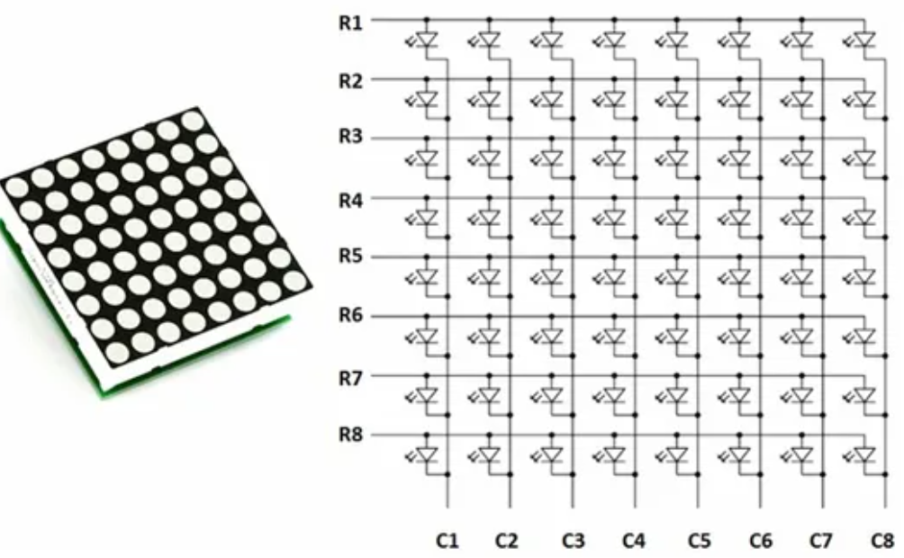

4. Experiment_ The LED matrix interfacing with PIC microcontroller
4.1 Coding:
- Open the MPLAB IDE and create a new project.
- Define the IO pins used for controlling (choosing) the desired speed levels and direction reversal.
- Output pins in order to send the direction control logic signal to the LED matrix.
- Write the main loop (routine) of the system.
4.2 Simulation:
- Using Proteus with PIC18 and port B is connected to different segments. fetch hex file and run the simulation.

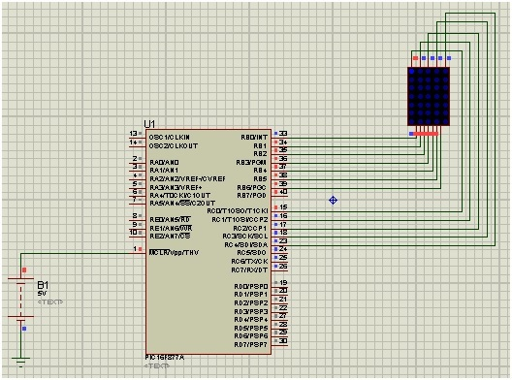

Figure . Circuit diagram
5. Homework
Write an C program for controlling the 7 segment display count up and count down.
Name: Student Code: Class: Lab:
- Circuit
- Algorithm flowchart
- Code and explanation
- Summary

